- Background

FSD Kenya and its current strategy

The Financial Sector Deepening Kenya (FSD Kenya) is an independent Trust dedicated to the achievement of a financial system that delivers value for a green and inclusive digital economy, while improving financial health and capability for women and micro and small enterprises (MSEs). FSD works closely with Government, the financial services industry and other partners to develop financial solutions that better address the real-world challenges faced by low-income households, enterprises and underserved groups such as women and youth. FSD’s current strategy (2022 – 2026) sets to contribute to the development of a financial market offering useful, affordable, and trusted financial solutions for Kenyans and Kenyan enterprises, especially for women and micro and small enterprises. The Strategy focuses on shifting 3 key functions of the financial market towards more inclusive finance. These functions are effective policy, regulation and vision, open financial market infrastructure and value adding financial solutions. Remittances is recognised as a key enabler to achieving Kenya’s long-term development goals as they enable socio-economic growth and transformation of livelihoods through their wide reach, especially to low-income households and rural populations. These flows enable livelihoods to manage day-to-day and increase their resilience through covering medical, educational and housing expenses as well as covering various emergencies such as crop failure and emergency medical treatment. They are also used to start and sustain small businesses.

IFAD and the PRIME - Africa programme

The International Fund for Agricultural Development (IFAD) has an on-going programme, PRIME Africa - the Platform for Remittances, Investments and Migrants’ Entrepreneurship, which focuses on seven African countries (including Kenya). The main objectives of PRIME Africa are to support the cost reduction of diaspora remittances, increase digitisation of the international remittances, foster the adoption of remittances formal channels, and increase the financial inclusion use cases through remittances. The project produced a diagnostic on the Kenyan remittance market in 2021, as well as an accompanying roadmap to guide activities to help make improvements to the market. The implementation activities following this include interventions that support both the private and public sector players.

Role of SACCOs in remittances

Remittances are important for Kenya and is an area that has been receiving increased attention in recent years. In many ways, Kenya has been seen as the ‘poster child of digital diaspora remittances, due, in many ways, to the widespread adoption of M-Pesa domestically since 2007. Kenya is a net receiver of remittances. According to the Central Bank of Kenya, official data shows that inbound remittances to Kenya totalled USD 3.7 billion in 2021, accounting for over 3 percent of GDP. Despite the progress that has been seen, there are still challenges with the remittance market in Kenya, with cost being a major barrier. Other challenges include lack of publicly available data that provides granular detail concerning flows, the channels used, who is using them, what their motivation is and what the money is used for; it is believed that there are large flows of informal remittances both into and from Kenya which by-pass the formal channels; and little is known about Kenya as a remittance-sending market. Further improvements could be made to assist financial inclusion if there were more physical networks in rural areas and other types of financial institutions, such as Savings and Credit Cooperative Societies (SACCOs) participating more in the remittances value chain; greater adoption of risk-based Anti-Money Laundering/Combating the Financing of Terrorism (AML-CFT) is needed; and little is known about the use of remittances by Mirco, Small and Medium Enterprises (MSMEs).

The opportunity

Both IFAD and FSD recognise the role of SASRA as a significant player in the remittances market. There are currently over 500 SACCO pay points countrywide with some of the large SACCOs rivalling commercial banks in terms of asset size and capital base. Whilst SACCOs currently offer remittance services, it is through agency relationships with commercial banks and other PSPs, mainly FinTechs that leverage mobile money services. This is by design as SACCOs currently cannot participate directly in the national payments system and cannot handle forex transactions. The current arrangements have several limitations: (i) they create several intermediary layers which add costs to the transactions thus making it more expensive to the end consumers; (ii) the integrations through partners create multiple points which cause vulnerabilities in terms of system failures and cyber-attacks, and (iii) banks need to get approvals from CBK before partnering with SACCOs which in turn have to get an approval from their regulator, SASRA, before partnering, leading to delays. These challenges limit the effectiveness of SACCOs as remittance providers. Addressing these challenges has the potential to:

- Increase inclusive finance through efficient and effective transfers, including reduced costs.
- Reduce the use of informal channels.
- Increase networks into rural areas by linking remittances with the financial services used by rural, low-income people such as women.

To get a better understanding of the SACCO remittances landscape it is vital that research as well as understanding the associated regulatory framework is undertaken. These would unveil opportunities that can inform how policies and private sector strategies could be shaped for enhancing the role of SACCOs in delivering remittances to support inclusive finance, especially for the Kenyan rural population. FSD Kenya, through funding from IFAD, seeks to recruit a Digital finance research specialist and a Policy specialist. The role of the Regulations specialist is to review the regulatory framework of the SACCO ecosystem and identify regulatory opportunities for both regulatory bodies and the private sector to support the mobilisation of remittances to SACCOs. On the other hand, the Digital finance specialist’s role is to undertake in depth primary and secondary research of the SACCO ecosystem with focus on identifying opportunities for remittances. Both roles will work closely together and need to be well co-ordinated for efficiency and leveraging emerging opportunities and synergies. FSD Kenya is thus looking for a Remittance Project manager to co-ordinate the work as well as co-ordinate with stakeholders involved in the project and handle the reporting of the progress made throughout the project cycle. The ideal candidate must have a good understanding of the remittances ecosystem in Kenya and is well skilled in co-ordinating several workstreams that are concurrently running. These terms of reference (ToRs) outline the scope of work for the Remittances project manager.

- OBJECTIVE

The remittances project manager (PM) is responsible for planning and managing the work under the SACCO remittances scope of work to ensure successful completion of listed objectives and deliverables. The PM will also be responsible for identifying and managing risks, careful resource management ensuring clear communication across multiple teams & reporting to the donor (IFAD).

- SCOPE OF WORK

The consultant will closely collaborate with the digital finance research specialist, the regulations specialist, the project team from SASRA, FSD Kenya and IFAD, throughout the project cycle, and as required.

The specific tasks to be undertaken are:
  - Ensure timely deliverable of project activities and outputs.

The project manager will review the activities and expected deliverables from the workstream and working closely with the consultants and other project team members, to ensure that these are done. These outputs must be of high quality and delivered in a timely manner. This will require review of the project documents including the Grant document, consultant’s ToRs and project schedule among others as shall be discussed at the inception meeting. Some of the tasks include:

- Ensure delivery of assigned deliverables
- Tracking project related risks
- Track project deliverables and progress
- Based on input from consultants, initiate and undertake procurement within agreed SLAs as shall be required
- Where required arrange meetings for technical staff with stakeholders or consultants and diarise accordingly.

  - Project monitoring, measurement and reporting.

The project manager will administer, monitor and evaluate the project regularly, in accordance with the regulations set forth in the grant agreement signed by FSD Kenya and IFAD. This will include:

- Develop a monitoring and evaluation tracking sheet/system to ensure that milestones, outputs and outcomes are achieved in due time. Progress will be tracked against the baseline data that should be available at project inception.
- Produce and share internal monthly and quarterly progress reports as well as milestone or checkpoint reports.
- Co-ordinate stakeholder physical and/or online meetings where key partners will be kept abreast of progress of the project. It is proposed that these are done weekly.
- Act as secretariat for project meetings and circulate minutes within 72 hours
- Report and track project results and outputs quarterly
- Track contract and vendor performance
- Coordinating evaluation and project reviews
- Tracking and enforcing contractual obligations
- Co-ordinate the project knowledge and learning events and gatherings.
Below is a summary of the project target outcomes and outputs

Outcome 1  - Recommendations to unleash the role of SACCOs as rural remittance providers are derived from the analysis of customers’ preferences to receive remittances through SACCOs, current and potential models to distribute remittances and regulatory issues faced by SACCOs  Indicators:  - Evidence-based recommendations collated in demand-side, supply-side and regulatory reports (3) | Related outputs  - Demand-side report showcasing the results of qualitative interviews and FDGs  - Kenya’s First National Remittances Household Study enhanced with additional questions on the role of SACCOs (4,400 households interviewed under the National Remittance Survey, 1 ad-hoc webinar to disseminate the findings from the household survey)  - 200 SACCOs and remittance users interviewed (120 interviewed and 80 participated in FGDs)  - Supply-side report showcasing current and potential SACCO models used to pay out remittances and related partnerships analyzed.  - 35 stakeholders interviewed (10 key informant stakeholders, 10 SACCOs, 15 SACCOs’ partners)  - Regulatory Diagnostic Report.  - 2 regulatory bodies involved through ad-hoc meetings
Outcome 2  Stakeholders involved in the SACCO sector and remittance value chain are aware of business opportunities under the current regulatory framework. Stakeholders validate and take ownership of recommendations made to bring the offer of international remittances through SACCOs at a broader scale with higher impact on rural financial inclusion for the benefit of a potential SACCOs clientele of 600 000 customers (50% rural).  Indicators:  Recommendations and research insight including an estimate of the untapped potential market for SACCOs validated by key stakeholders and broadly shared in a final report and workshop | Related outputs  - 3 workshops (divided by audience: remittances users, providers and regulators) to validate and refine the report analysis and recommendations and generate ownership  - 200 persons involved at the consultative workshops (50 from demand-side, 125 from supply-side and 25 from regulatory bodies)  - 3 summary documents outlining opportunities challenges and recommendations prepared for the demand-side, supply-side and regulatory recommendations.  - 1 final publication with the research findings and recommendations  - 1 dedicated in-person event to disseminate the knowledge findings; at least 100 relevant participants attending final event.  - At least 2 National Remittances Stakeholders Network (NRSN) Community of Practise (CoP) meetings  - SASRA, IFAD and FSD Kenya websites disseminate the project knowledge

- CONDUCT OF THE WORK

The Project manager will report directly to the overall project lead who is also FSD Kenya’s Senior Digital Financial Payments specialist, working closely with the research and policy specialist and project teams from SASRA, IFAD and FSD Kenya. The role does not require physical presence in the FSD office, but from time to time, where physical meetings are being held, s/he will be required.

- OUTCOMES AND DELIVERABLES

The key outcome sought from this assignment are ensuring the delivery of quality and timely deliverables. The table below specifies the expected deliverables.

Activity | Deliverables
- Inception meeting to clearly outline the expectations including full understanding of the deliverables and timelines | - Detailed Implementation plan
- Ensure timely deliverable of project activities and outputs | - Deliverables from the consultants s/he received on time and within the agreed timeframe and are of high quality.
- Project monitoring, measurement and reporting. | - Monitoring and evaluation tracking sheet/system  - Quarterly progress reports  - Weekly progress meetings  - Track contract and vendor performance  - Coordinating evaluation and project reviews  - Tracking and enforcing contractual obligations  - Co-ordinate the project knowledge and learning events and gatherings.  - Track the budget spend.  - Regular reports to IFAD

- REQUIREMENTS

Mandatory requirements
- A relevant qualification in social science or related degree (minimum bachelor’s degree, masters preferred)
- At least five years of experience in a similar role with a reputable organisation working with SACCOs and remittances
- Experience working in the development field (preferably with a market development lens)
- A solid understanding of the remittances and payments regulatory system in Kenya as well as understanding the associated value chains (policy and industry stakeholders, channels, solutions etc). Understanding of the internal regulatory systems of the same will be an added advantage
- At least 5 years of experience managing projects using project management best practices
- Experience in collecting and analysing data
- Proficiency in Microsoft Office applications
- Ability to work independently and deliver against deadlines.
- Proven experience of working with highly technical and specialised organisations as well as have strong stakeholder co-ordination skills
- Excellent spoken and written English with good communication and presentation skills

- EVALUATION CRITERIA

Evaluation criteria (provide response in TECH FORM)
Criteria, sub-criteria, and point system for the evaluation of Technical Proposals |  | Weighting (%)
1 | Experience and qualification of the Consultant (evaluated via forms TECH-2)
1.1 | Track record and experience with project management | 15
1.2 | Experience working with SACCOs and remittances | 15
1.3 | Experience in collecting and analysing data | 5
1.4 | Understanding of the regulatory payments and remittance ecosystem of Kenya | 5
 | Experience working in the development field | 5
 | Proven experience of working with highly technical and specialised organisations | 5
 | Total Points for this criterion | 50
2 | Approach and methodology (evaluated via forms TECH-4)
2.1 | Quality and relevance of the implementation plan | 10
 | Total Points for this criterion | 10
3 | Staff schedule, work and deliverable schedule (evaluated via form Tech 6,7 & 8)
3.1 | Ability to work independently | 5
3.2 | Availability and responsiveness to deliver the work | 5
 | Total Points for this criterion | 10
4 | Key Professional Personnel Qualification for the Assignment  Note: Bidders to include CVS using TECH FORM-9 and supporting certifications of ALL KEY PERSONNEL. Bidders to respond in relation to the Key personnel requirement and evaluation criteria in this section
4.1 | Relevant academic qualifications | 5
4.2 | Expertise and skills in stakeholder co-ordination | 10
4.3 | Expertise and skills of the consultant to communicate and disseminate | 15
 | Total Points for this criterion | 30
 | Total Points for the four (4) technical criteria (St) | 100
 | The minimum technical score St required to pass for financial proposal to be scored is | 75
Financial Evaluation
The formula for determining the financial scores is the following:

FS = 100 x FL / FP, in which FS is the financial score, Fm is the lowest price and FP the price of the Proposal under consideration.

The weights given to the Technical (T) and Financial (F) Proposals are:

T = 80% and F = 20%

- TIMETABLE

The outputs are expected over a period of 60 days spread over a period of 18 months beginning June 2023 and completed in Dec 2024. A summary schedule is included below:

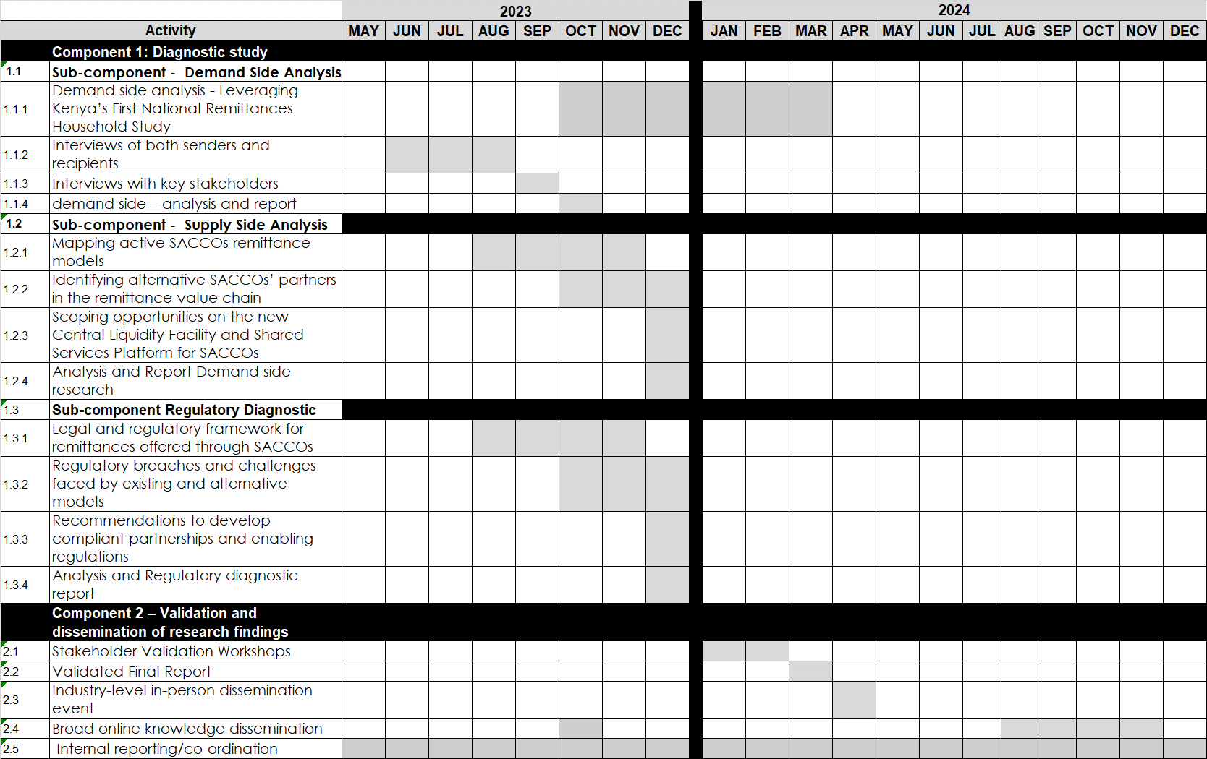

- SUBMISSION

Interested bidders should send proposals by email to tenders@fsdkenya.org on or before June 16th, 2023, at 17:00HRS (EAT) with the subject line “REMITTANCE PROJECT MANAGER REGULATIONS SPECIALIST CONSULTANT”.

If you have any clarification questions, please email us at tenders@fsdkenya.org no later than 12th June 2023. Responses to clarification questions shall be sent on 13th June 2023.

FSD Kenya will undertake a due diligence assessment and screening of the preferred Bidder to include reference checks. FSD Kenya will share a Third-party screening questionnaire to aid in processing the assessment and screening. FSD Kenya reserves the right to proceed or reject Bidder(s) depending on the outcome of this assessment and consider the next ranked bidder. The findings of this assessment will be kept confidential and used internally for the purposes of this evaluation.

FSD Kenya reserves the right to accept any tender (s) or to reject all tenders at any time. FSD Kenya also reserves the right to cancel this procurement at any point in time prior to award of the contract.

If you would like to lodge a complaint regarding this procurement process, please write to tenders@fsdkenya.org with the address regulations specialist consultant”. FSD Kenya procurement team will acknowledge receipt of the complaint in writing within three (3) working days.

During the course of this procurement if you come across any issues of bribery, corruption or wrong doing on FSD Kenya part, please feel free to contact Julius Anyega, FSD Kenya Chief Operations Officer at Julius.Anyega@fsdkenya.org or transparency@fsdkenya.org

Tender security is NOT required. Issuance of this request for proposals in no way obligates FSD Kenya to award a contract. Applicants will not be reimbursed for any costs associated with their application.

